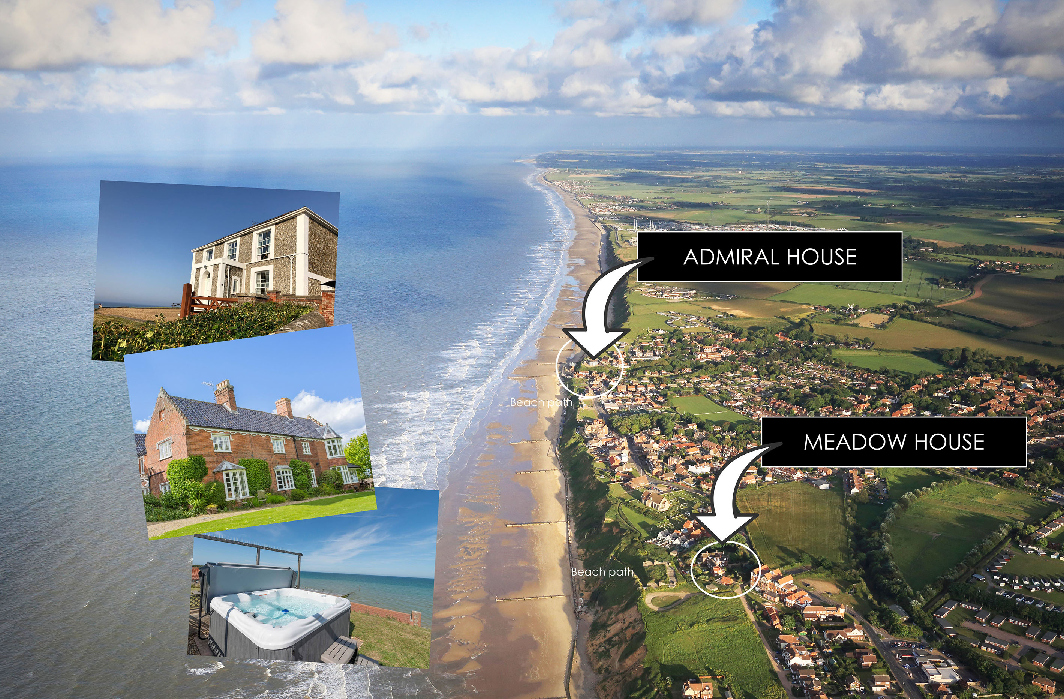

Welcome to Admiral House

Booking Confirmation, please complete and return with payment within 48 hours.

Name: Numbers attending

Booking date from-until:

Email contact

Tel Number

Address

Deposit on booking, balance due 60 days before arrival.
£
£
Price Quoted Pay deposit of 50%

Prices on our website www.norfolkbeachhouse.co.uk

SECUIRTY DEPOSIT

A security deposit £250.00 (£400 for Hen Parties) required on all rentals paid with the balance. Refunded in full after your visit.

LINEN & TOWLES

Linen is included: bed sheets, duvets slips and pillow cases and a bathroom towel (We do not supply BEACH towels).

DEPOSITS

- Non-refundable 50% deposit required on all bookings (see full terms below T&C 3 & 4)
- Balance in full due 60 days before arrival
- £250 security deposit required 7 days prior to arrival, refunded in full post visit by BACS
- 2020 Covid 19 deposits – during the current crisis our terms are 25% deposit and balance 60 days before your arrival. Should the Covid 19 Government travel restrictions still be in force on your arrival date we will refund in full up to 14 days before arrival.

REFUNDS

- Refunds – we offer a full refund if we can rebook the date requested. To avoid guests holding popular dates and not completing a bookings, we charge a 15% of the deposit admin charge for cancellations if we refund you.

- We are unable to offer any refund within 14 days before arrival.

PAYMENT

Deposit and Balance payments to:

BACS to :
Halcyon Management Ltd
208458
73285286

Mark your payment ADM (Date) e.g. ADM 150220

Cheque (BACS preferred) : Halcyon Management Ltd The Lodge, 7 Church End, Wiltshire SN54EB Mark your payment ADM (Date) e.g. ADM 150220

PRE CONTACT

Tel: 01793 772999 Mob 07545 501763 E: simon@planetpursuits.com
Welcome instructions and key arrangements follow once balance payments are received.

ON ARRVIAL

Paul (House manager) 07930331972
Shopping Orders
You can arrange a shopping order to be left in the inner hall (behind the house) before arrival, please call to organise Paul (House manager) 07930331972

HOT TUB TERMS

We have very strict terms on the hot tub and its use and cleanliness, your deposit will be at risk.

- Hot tub - no permitted use after 10pm and 8am for any purpose on any date.
- Please respect our neighbours at all times with noise
- No more than 5 people and children under 12 must be supervised
- Hot tub cover must be replaced immediately after use
- We do not provide Beach Towels and house towels are not to be used on the beach


ARRIVAL AND DEPARTURE

Unless previously agreed

Full week Fri 16.00 until Fri 10.00

Weekend Friday 2pm until Noon Sun or 10am Mon as agreed for 3 days

Please ensure you have departed at the agreed times to facilitate cleaning!

Liability: It is important to understand you are renting the property under private agreement and therefore we cannot accept any liability for any damage, injury, theft or loss incurred during your stay at the property. If you are concerned about the liability or any loss during your stay you must make provision for your own cover.

Property Protection: As a paying guest we also ask for you to take these minimum precautions, whilst engaged in a short-term rental for the protection of the property and your own health and safety.

- When the property is vacant for any period, all doors and windows to be closed shut and locked where appropriate.

- All electrical appliances to be switched off on departure, except for fridge’s, heating and the boiler.

- Small children to be supervised in the Kitchen and Bathrooms, also please be aware there are many valuable antiques and paintings.

- On arrival please ensure you familiarize yourself with the welcome notes, safety equipment and minimum conditions on departure.

- Children are supervised in and around the Hot tub area and you accept liability for maintaining the Hot tub and the provision of safety for your guests. No use after 10pm and noise restrictions in force at all times.


Please sign below to confirm you have read and understood this booking confirmation.

To e-sign – return with a deposit payment, which constitutes a legal agreements between both parties

Or sign

SAFETY WARNING
Safe areas for dogs and small children - Warning! Our garden has a walled area to the road and large entrance gates, but the seaward side is not secure. We are also on the edge of a small Admiral facing the sea. Dogs and children can gain access to the sea and Mund beck (small stream) from the garden. We have two secure courtyards with swing back gates to allow dogs to stay and children to play safely. Please note there is no fence between us and the sea.

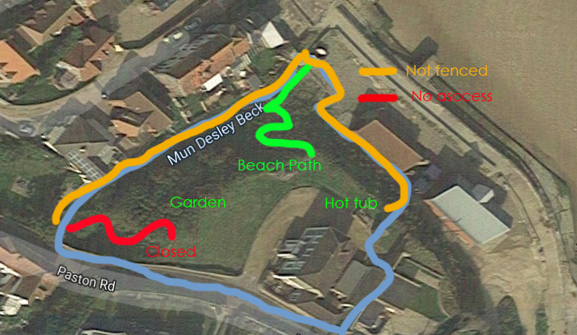
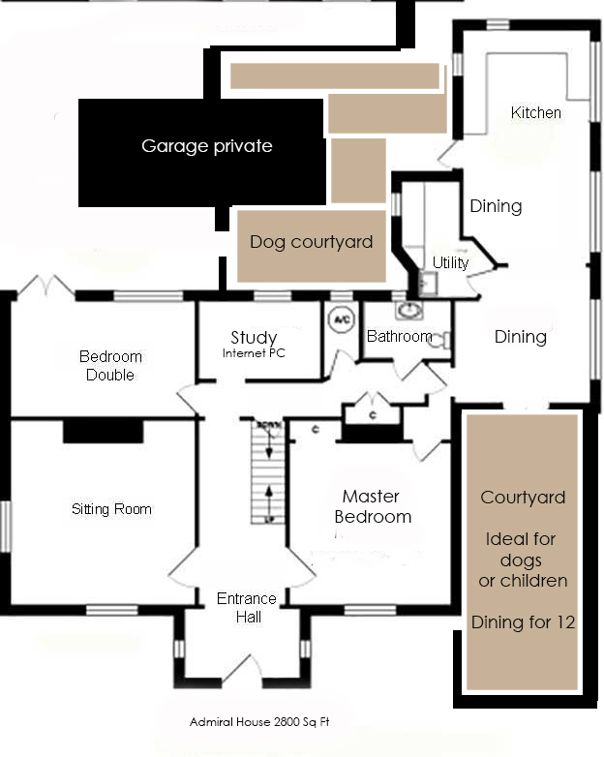

Terms & conditions of Hire
Legal Jurisdiction
This agreement (and any disputes, claims or proceedings of whatsoever nature arising) shall be governed by and shall be construed in accordance with the laws of England. The hirer hereby consents to the exclusive jurisdiction of the English courts in all disputes.
1. Weekly hire
All weekly bookings start from 4.00pm on Friday/Saturday (or the day agreed) and the property must be vacated by 10.00am on the Friday/Saturday (or the day agreed) that the period ends. However if we have no bookings either side of the weekly booking we aim to be flexible on arrival and departure times.
2. Short Breaks Hire
Short break bookings start from 2.00pm on the agreed start day (Friday) and the property must be vacated by noon Sunday or 10am Mon as paid and agreed. However, if we have no bookings either side of the short break we aim to be flexible on arrival and departure times.
3. Deposit/Payment
Payment is divided into three amounts and should be made as follows:
- a non-refundable deposit of one half (1/2) of the full amount at the point of making the booking
- where a deposit is agreed of less than 50% we will request the balance of deposit 6 months before arrival date
- the final one half (1/2) is due 60 days before arrival date
If the booking is being made within 8 weeks of the date of hire, the full amount of the hire charge is payable.
You may make a provisional booking by phone or email, and, once the dates have been agreed, this will be held for a maximum of 3 days. Your deposit payment and booking form must be received within 3 days of the phone or email confirmation or the accommodation will be released on the calendar.
If the balance is not received by the due date the deposit will be forfeited and the accommodation may be re-let.
4. Cancellation & Refunds
All deposits and balances are non-refundable, however should you cancel and we can re-let the property we will refund you in full. To avoid clients holding and releasing popular dates we charge a 15% administration charge of the deposit paid.
Balance due 60 days before arrival.
If cancellation takes place after all monies have been received by the accommodation owners no refund will be made unless the property is re-let in which case 85% of the amount paid will be returned.
Should the owners of Admiral House have to cancel the holiday, every effort will be made to find suitable alternative accommodation. If this is not possible a refund will be made of all monies paid by the hirer to the owners of Admiral House for the accommodation. No further financial claims against the owners will be considered.
5. Holiday Insurance
Once booked, the hirer is liable for the complete cottage rental costs. As such it is strongly recommended that the hirer take out suitable holiday insurance to cover costs incurred by unexpected holiday cancellation.
6. Shopping Orders
You can arrange a shopping order to be left in the inner hall (behind the house) before arrival, please call to organise Paul (House manager) 07930331972
7. Availability
The booking is made on the understanding that the House will be placed at the hirer’s disposal on the dates agreed. Should this not be possible through fire, theft or circumstances beyond the owner’s control, the full amount paid by the hirer will be refunded. However note that no alternative accommodation can be provided nor will the hirer have any claim against the owner for compensation, loss or expenses. The accommodation is booked strictly on the basis that it is used for holiday accommodation only and there is no right to remain on the property after the expiration of the rental period.
8. Breakages
The hirer undertakes to keep the House and all the furniture, fittings and fixtures in the same state of repair and condition as at the commencement of the letting. The owners must be informed of any breakage. Should the damage result in another booking being cancelled the hirer will be held liable for all consequential losses to the owner.
9. Occupation
The hirer shall use the accommodation strictly for private holiday occupation and this agreement shall not confer on the hirer any security of tenure within the terms of the Housing Act 1988 pursuant to which the occupation shall be deemed to be by way of an excluded tenancy. The hirer shall not do or allow to be done anything which may become a nuisance or annoyance to the occupiers of the neighbouring properties. The hirer shall not allow any person or persons to sleep in or otherwise occupy the accommodation except as specified on the Booking Confirmation letter. If this is not observed, the owner reserves the right to refuse admittance or require that the hirer vacate the property. In this eventuality no refund of monies will be due.
10. Repairs
The hirer shall permit the owner to enter the accommodation at any reasonable time of day to inspect the condition of the decorations for the purpose of carrying out repairs that may be required to be done.
11. Safety
The owners take safety very seriously and do everything to ensure the house is safe, however your stay at the House is entirely at your own risk. The owners can take no responsibility whatsoever for any accident, injury or loss, howsoever caused, during your stay. This includes the use of the hot tub, bbq, garden games and activities. If you are concerned about any safety aspect, please immediately call the house manager.
12. Smoking
For safety reasons we ask that guests do not smoke within the house. You may smoke in the garden, please dispose of cigarette butts carefully.
13. Service
If you should encounter any problems during your stay, or if you are dissatisfied with the service you receive, you should refer to the owners immediately. The owners will take all reasonable steps to correct any problems arising. The owners will not consider claims for problems notified to them after the stay has ended.
14. Amenities
The use of the house includes gas, electricity, water, heating, bedlinen, towels, cleaning products, bathroom toiletries, use of TV/DVD, Hi Fi, WiFi, Broadband, hot tub. White towels are to stay in the house, beach towels are not provided for beach use. The hirer is also entitled to use anything left in the house
15. Cleaning
The house, any equipment used and utensils etc must be left as it is found at the end of the hire period. Your £250 cheque will be returned to you if the house is left in a satisfactory state. The hirer must take responsibility to make sure all cleaning products are kept out of the way of children.
16. Left items
The hirer will be notified of any of the hirer’s possessions that have been left at the house after it has been vacated. The hirer must meet the cost of any items returned to them, or if they do not wish to have them returned, the owner will dispose of them. The owner accepts no liability for the hirer’s items getting damaged in transit whilst being returned.
17. Security
The hirer is responsible for the security of the house for the duration of the booking period The hirer is expected to take all reasonable care of the house. The house must be fully secured after leaving it. No windows should be left open and all locks must be secure. When finally leaving the house on the day of departure all keys must be left on the kitchen table for the owner.
18. Parking
Norfolk Beach House (Admiral)has parking for four hot tubces outside the house, we do not accept any liability for your cars parked on our property.
19. Complaints procedure
If the hirer is not fully satisfied with the accommodation offered they must immediately contact the owner and every effort will be made to resolve the problem. If the situation cannot be resolved to the satisfaction of both parties, the owner will attend as soon as possible to inspect the property. The owner will not consider claims for problems notified to them after the hire period has ended.

19. Variation to descriptions and Terms and Conditions
Every care has been taken to ensure the accuracy of the details on the owner’s literature, website and advertising. However changes may be necessary from time to time and the owners reserve the right to make changes without notice. These may included changes to our terms and conditions which will be updated on our website.
21. Hot Tub
The hot tub is used entirely at your own risk. The hirer is responsible for guest’s safety, the use, condition and compliance of rules as stated in the terms and condition of rental and additional notes provided on completing payment. The hot tub and its associated cover is presented in a clean and sanitary state at the start of the rental. If the hirer is not fully satisfied with the hot tub condition they must immediately contact the owner and every effort will be made to resolve the problem. The hirer must ensure the shower is used for the hot tub before use, the hot tub is kept clean, no fake tan and no drinks are consumed in the hot tub.

